Concept plan of Technical Module

# **Setting Objectives**

* To Create the data set where we can learn and manage the design and drawings that are being submitted by the Contractor.
* To create a library for technical team. It will contain all the design and drawings. It will also contain the technical subject knowledge lectures that will benefit the team to create a strong basis.
* To create the strong technical community.
* To help the BD team while accessing the companies’ credentials and experience.
* To create a business opportunity in future company regarding management the data of Contractors. Also, to create the business of providing the college civil students regarding the designs that happen in civil industry.

# **Developing Planning Premise**

* The main concern of the creating the data set is that there is some possibility that the data repetition will be there.
* It is assumed that we can save the contractor’s created drawings can be saved on the server and can be used for company’s purpose.
* It is assumed that the created module will get implemented in the Rodic hub and not in the PPMS.
* It is assumed that we can create a bridge between this module and the LMS platform.

# **Identifying Alternative Courses of Action**

* PSA: creating the document system for adding the data in the required format given in the upcoming annexure. Regarding subject knowledge lectures we can directly add the same on the LMS.
* Adding the data to the 3d models that are being created in the PPMS.

# **Evaluating Alternative Course of Action**

|  |  |  |  |  |
| --- | --- | --- | --- | --- |
| **Sr no** | **Evaluation basis** | **Technical module** | **PSA** | **PPMS** |
| 1 | How the objective Is being achieved from the solutions | We will create the module in Rodic hub | We will create the folders. For technical knowledge purpose we will add the LMS courses and for the design review process we will use process we are using till yet. | In the PPMS we will add the data to 3d models. And for learning the technical module we will use the LMS. And for the review process we will proceed with the older one. |
| 2 | accessibility of design and the drawings | The accessibility will be higher as the model is specifically targeting the design and the drawings. | The accessibility is low as it does all the data is being added in different in the projects and there is no specific option for adding different types of the data in the same | accessibility will be higher, but it is not created yet. |
| 3 | risk | risk for creating the technical module is that the data formats has not created yet so it will be significant of data formats creation. And the person who will add the data should have good knowledge about the subject. There is a large possibility of repetition of data | Risk of PSA is that we need to create the new formats on it and the designs that are already being uploaded will not reflect and it also will not have the functionality of the design review and community. | The models that are not created yet so attaching the model is still in the development phase. So, it will take time. |
| 4 | Conclusion | The technical module is necessary because of the functionality. | We can add the folders for uploading documents but still need to confirm from the experts | Need to confirm from the expert’s whether we go with the technical module or the attaching the 3d module. |

# **Selecting One Best Alternative**

* We are going with the technical module as it provides the most value
* Creating the questionnaire and asking the employees directly.

# **Implementing the Plan**

1. For creating the technical module following will be final view
2. Process flow of Each Tab

* Process of Design review Tab.

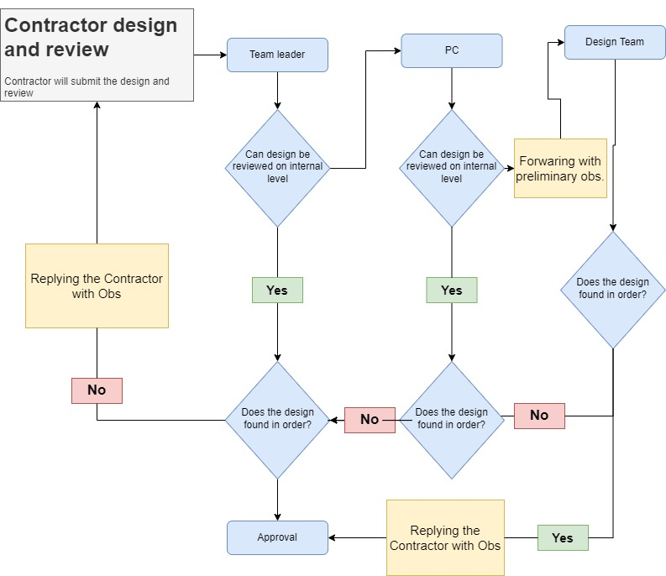

* Process of Community Tab

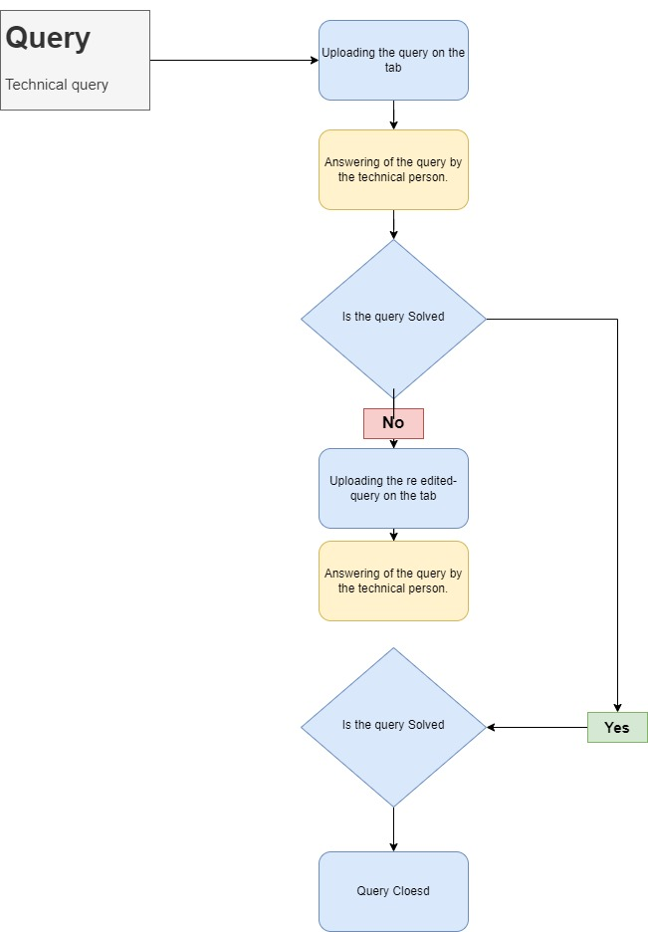

* Process of learning tab

1. Form of different Tab

* Form of uploading the technical document (each document): - Highways
* Form of Community Tab

1. Who will be held responsible for keeping tab on?

# **Follow Up Action**

* How the success of each module should be measured.
* Monitoring the plan constantly and taking feedback at regular intervals is called follow-up.
* Monitoring of plans is very important to ensure that the plans are being implemented according to the schedule.
* Regular checks and comparisons of the results with set standards are done to ensure that objectives are achieved.

# 